**Batch: D2 Roll No.: 25**

**Experiment / assignment / tutorial**

**No.____1___**

**Grade: AA / AB / BB / BC / CC / CD /DD**

**Signature of the Staff In-charge with date**

# PCB Workshop (2021-2022)

**Design and Manufacturing of Printed circuit Board (PCB).**

**Post Lab Subjective/Objective type Questions.**

1. **Describe the function of double sided UV Exposure unit.**

Ans. This uv exposure unit can be used to print PCB artwork onto the photosensitive surfaces of a Printed Circuit Board (PCB). With this device one can manufacture his own PCBs (printed circuit boards) according to the photolythography method for PCBs.

The unit is capable to create doubled-sided exposures on both the top and bottom PCB surfaces at the same time. Double sided exposures take about 160sec to be completed.

The device has been designed for positive photoresist; that is, UV exposed areas can be etched away on the final PCB. Artwork should have opaque tracks on a transparent background. Using consistent methodology, you will be able to produce PCBs with track width and spacing down to 0.2mm.

1. **List the software’s used for PCB layout design and explain how to design layout using DIPTRACE or EAGLE software.**

Ans. The softwares used are:

* KEYCAD EDA
* DIPTRACE
* EAGLE
* EASYEDA

The steps for creating PCB design on Eagle are as follows:

* First using the given circuit diagram, create a schematic in Eagle under a new project
* Then switch to board view and drag all components onto the board. One can also resize the board if needed
* After dragging all components onto the board and arranging them in an organized manner, such as to avoid shorting among traces, select the autorouter
* The autorouter will automatically arrange components in an organized manner and offer several variations for the same based on given criterias. Select any one
* Add text to the board itself and then export it in any format you deem necessary

**3. Write and explain in short the steps for fabrication of PCB**

Ans. PCB fabrication is the process or procedure that transforms a circuit board design into a physical structure based upon the specifications provided in the design package. This physical manifestation is achieved through the following [**techniques**:](https://resources.pcb.cadence.com/blog/pcb-fabrication-techniques-2)

* Imaging desired layout on copper clad laminates
* Etching or removing excess copper from inner layers to reveal traces and pads
* Creating the PCB layer stackup by laminating (heating and pressing) board materials at high temperatures
* Drilling holes for mounting holes, through hole pins and vias
* Etching or removing excess copper from the surface layer(s) to reveal traces and pads
* Plating pin holes and via holes
* Adding protective coating to surface or solder masking
* Silkscreen printing reference and polarity indicators, logos or other markings on the surface
* Optionally, a finish may be added to copper areas of surface

**4. Explain PCB in details.**

Ans. A printed circuit board (PCB) is an electronic circuit used in devices to provide mechanical support and a pathway to its electronic components. It is made by combining different sheets of non-conductive material, such as fiberglass or plastic, that easily holds copper circuitry.

PCB is also known as printed wiring board (PWB) or etched wiring board (EWB).

A PCB works on the copper films/assembly/circuit that are placed inside of it to provide a pathway for the flow of current. A PCB can hold various electronic components that may be soldered without using visible wires, which facilitates its use.

PCBs are found in nearly every electronic and computing device, including motherboards, network cards and graphics cards to internal circuitry found in hard/CD-ROM drives.

**5. Draw any one electronic schematic diagram with its PCB Layout.**  Ans. The Schematic diagram with PCB is as follows:

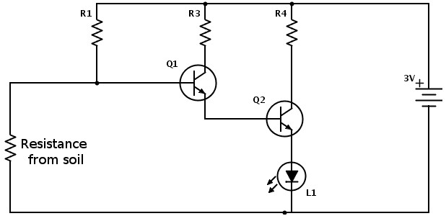

**PCB Layout:**

